Hispanic Studies Faculty and their Areas of Expertise
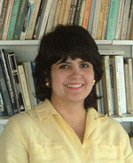

Patricia Anderson, Instructor PhD, Boston Collage
She specializes in Medieval Castilian literature. Her doctoral dissertation examined in detail the Castilian legal code Siete Partidas. She teaches all levels of Spanish language.

Aída Belansky, MA, Universidad Católica de Lima.
Journalism & Public Relations. Joined UMB in 1999 and teaches all levels of Spanish language

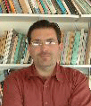
Jean-Philippe Belleau, Ph.D. candidate at the Institut des Hautes Etudes d'Amérique Latine, Université Paris-III Sorbone Nouvelle. He conducted research in the Brazilian Amazon and in Haiti and worked for several years in human rights with the United Nations, the OAS and various NGOs. He joined UMB in 2000 and teaches Latin American Studies.

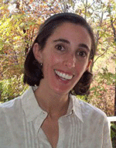
Juliana Berte, MA, University of Minnesota
graduated from Universidad Nacional de Córdoba (Argentina), where she is originally from, in 1998, with a degree in Spanish Language and Literature. In Córdoba, she worked as a high school literature professor from 1995-1999. In 2002 she completed her M.A. in Hispanic Linguistics at the University of Minnesota, where she also taught all levels of Spanish. She Joined UMB in 2002 and currently teaches a variety of courses, including online courses.

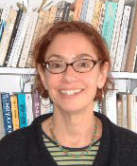
Ann Blum, PhD (Latin American History), University of California, Berkeley.
She assumed her tenure track position in Fall 2000. Her research examines the relationship between family and state formation in modern Mexico, with a focus on urban child welfare. Her publications have been honored with awards from professional societies. She has reviewed manuscripts for Princeton University and the Smithsonian Institution Press.

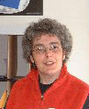
Reyes Coll-Tellechea, (On leave 2004–2005) PhD (Hispanic & Luso-Brazilian Literatures and Linguistics), University of Minnesota.
A scholar of Early Modern Spain, she edited a critical edition of La Vida de Lazarillo de Tormes (Madrid, AKAL 1997 and 2000) and has published articles on the Spanish Picaresque novel, contemporary Spanish literature, the place of history in Spanish literature, and language as cultural capital. She is currently working on a book project on the subject of history in Spanish literature.

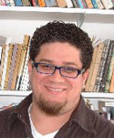
Jason Cortés, PhD Pennsylvania State University (Spanish American Literature)
Jason Cortés joined the Department of Hispanic Studies in the Fall of 2002. His training in Spanish American literature focuses on 20th century narrative, with a primary emphasis on Caribbean literature, and cultures. His research interests include: Puerto Rican literature, literature and philosophy, Afro-Hispanic studies, literary theory, and the ethics of writing. His doctoral dissertation "The Ethics of Authorship: Literary Authority in Contemporary Spanish American Novel" examines the relationship between writing and violence in Spanish America, specifically its impact on ethics and authorship. Prof. Cortés has published articles on the topics of violence and representation in Griselda Gambaro's theater, and ethics and identity in Manuel Ramos Otero's short stories.

Charles Dietrick, PhD (Spanish American Literature), University of Wisconsin at Madison. Joined UMB in 1985. He is an expert on Web-based foreign language teaching. He teaches all levels of Spanish. On leave fall and spring, 2004-2005.

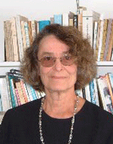
Clara Estow, Chair, PhD (History of Ideas), Brandeis University.
A student of Spanish medieval culture and institutions, she has written extensively on a variety of historical and literary subjects and is currently completing a manuscript on gold in the Middle Ages and the Early Modern Period. She is a member of the editorial board of a journal in her field and is frequently called upon to referee and review manuscripts and books on Spanish medieval subjects.

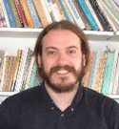
Emilio Pozo García, PhD, Universidad de Alcalá
He has just joined the department of Hispanic Studies from Madrid Spain. He got his Ph.D. from the in Filología Hispánica from Universidad de Alcalá. He has been doing research and writing about postmodern readings of the work of Jorge Luis Borges. His doctoral dissertation was entitled “Contextos de lo posmoderno en la obra de Jorge Luis Borges.” His current project at Harvard University is to reread again Borges's work in the light of the new Latin American cultural theories. His objective for this academic year is finishing his book J. L. Borges: de la sensibilidad del límite, and various articles.

Leonor Figueroa-Feher, PhD (Latin American Literature), Harvard University.
She has taught a variety of undergraduate and graduate-level courses in Latin American Literature and Spanish language in Harvard University, Boston College and UMASS-Boston. She developed the oral translation component for UMASS's Certificate in Spanish Translation program, and is now coordinator and head instructor for the Certificate program in Spanish Court Interpretation. In July 2001, Dr. Figueroa-Feher was appointed Training Manager at the Office of Court Interpreter Services for the Massachusetts Trial Court. She is a state-certified court interpreter, with years of experience working in the Massachusetts judicial system and in the Supreme Court of Puerto Rico
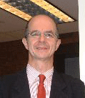
Jacobo Gutiérrez, MA, University of Warwick, England, 1997.
He joined Hispanic Studies in 2000 as Director of the Spanish Resource Center. He is an expert in Foreign Language Education.

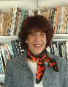
Beatriz Iffland, MA (Latin American Literature), Universidad Nacional de Córdoba (Argentina).
She joined MB in 1975. She has published two Spanish as a foreign language textbooks; she teaches all levels of Spanish. On leave Fall 2002.

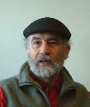
Ildefonso Manso, M.Ed., Escuela Universitaria de Profesorado Pablo Montesino, studied philosophy and psychology at the Universidad Complutense de Madrid as well as theology and religion in Spain and Argentina.. He teaches all levels of Spanish.

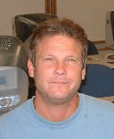

Mark McCarthy
He has lived in the Dominican Republic, Nicaragua, and Colombia. He is currently completing a graduate certificate in The Teaching of Spanish as a Foreign Language here at UMass.

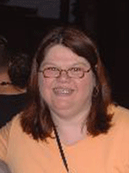
Susan Mraz, Language Coordinator, MA (Foreign Languages: Spanish & ESL),West Virginia University.
She is co-author of Introductory and Intermediate programs for Spanish as a foreign language. She is an expert in Teaching Methodologies and Technology in the Language Classroom. She joined UMass-Boston in 1999 and teaches all levels of Spanish Language. In addition, she teaches the technology courses for the Graduate Certificate in Spanish Teaching

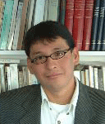
Henry Rafael

An accomplished Peruvian journalist, Henry is currently at UMB’s McCormack Graduate School of Public Affairs. He teaches languages courses.

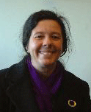
Clara Eugenia Ronderos PhD candidate at the University of Massachusetts, Amherst is visiting us this year. After teaching at Universidad de Los Andes in Bogotá Colombia, Clara has been at University of Massachusetts Amherst where she has pursued a doctorate in Spanish Literatures and Linguistics. During her years at Amherst, Clara specialized in Hispanic poetry with a concentration on nineteenth century Spanish America. Other areas of interest are Spanish American Literature, Peninsular Golden Age, Literary Theory, Translation Theory and practice, and Postcolonial Studies. She recently attended the Latin American Studies Association where she read a paper on Rubén Darío and his construction of Spanish American cosmopolitism.

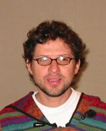
Libardo Rueda, MA (Applied Linguistics), University of Massachusetts, Boston
Originally from Colombia, Professor Rueda has his MA in Applied Linguistics from UMass Boston. In addition to teaching language courses, he is a member of the Human Rights Working Group at UMass. He’s also a master chess player.

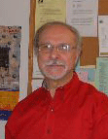
Caetano Serpa, PhD Gregorian Pontifical University, Rome
Originally from the Azores, he has published extensively and teaches the department’s Portuguese courses

Esther Torrego, PhD (Romance Philology), Universidad Complutense de Madrid.
One of the most distinguished experts on Spanish Theoretical Linguistics, she has published extensively in this field, including a book, The Dependencies of Objects (MIT Press, 1998). She is a member of several editorial boards in her field and is frequently called upon to referee and review manuscripts, abstracts and books on theoretical linguistics and numerous Ph.D committees at prestigious universities in the United States and abroad.

